**FSA STORE SETUP**

Participants must have access to their Summit Portal. If you have not set that up, contact Chris Mabry or Heather Crossman at Pension Concepts. 806-745-9781

***The FSA Store will only work on the website, not the mobile app.***

Login to the Summit Portal. Once there, verify your email address and mailing address is correct.

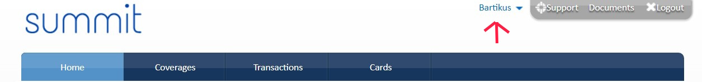

Once those are correct, navigate to the left side, under your FSA benefit. Click the blue FSA Store link. There will be one for each benefit year (two during grace period):

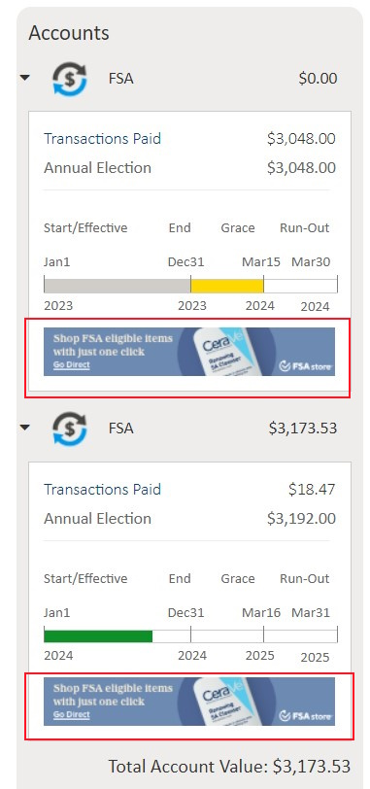

You will be sent to the FSA Store website. You will be asked to create an account. Fill out all information needed. Your balance will be displayed on the right side:

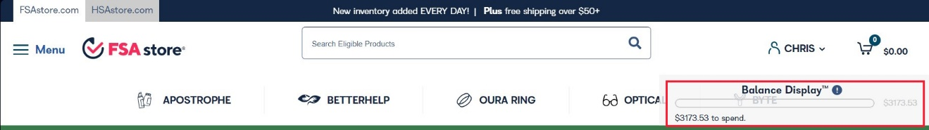

Click the left side Menu to view other options:

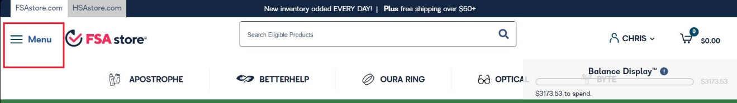

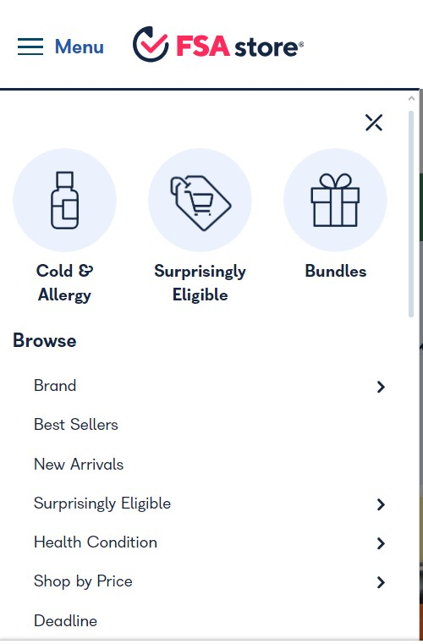

There will be a shipping charge on all orders less than $50.

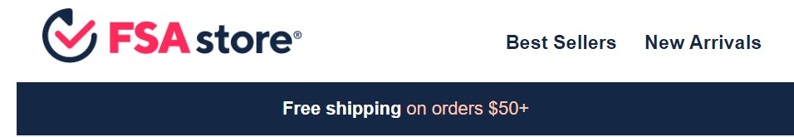

Browse through the website, purchase items as you would any other site. Once you proceed to check-out, you will be given a “Direct-Pay” option. This will charge your FSA benefit. You do not need your card. You do not need to turn in a manual claim or receipts. Once you click “Place Order”, you are done.

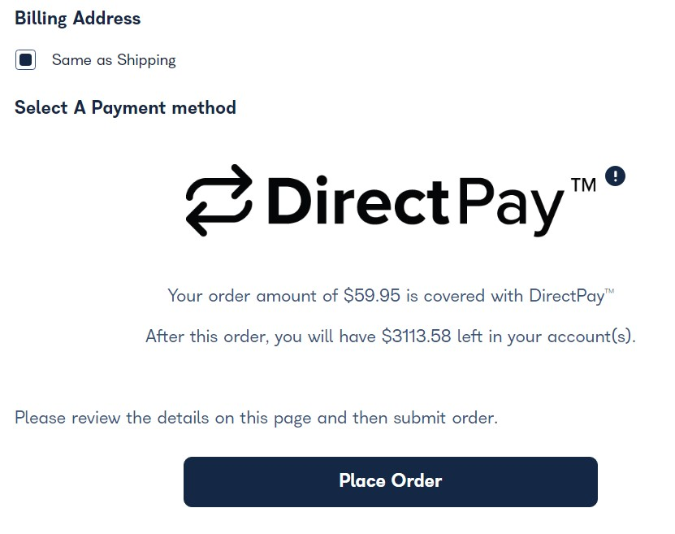

***Often participants have had difficulty buying OTC items and durable medical devices at local stores. This site should help in those circumstances.***

If you have any questions, please contact:

Chris Mabry - 806-745-9781 x.6

[cmabry@pensionconcepts.org](mailto:cmabry@pensionconcepts.org)

Heather Crossman – 806-745-9781 x.2

[heather@pensionconcepts.org](mailto:heather@pensionconcepts.org)