**ONLINE CLAIMS ENTRY**

A participant can now send in claims by fax, email, mail, drop off at our office and online claims entry**. ONLY USE ONE METHOD TO SEND IN CLAIMS TO AVOID DUPLICATION.** If a claim is sent in more than once, or is sent in by two methods, this could delay processing and payment by a month or more. You must have your Summit Portal setup to use online claims entry. If you need help setting up your portal, call Chris Mabry @ 806-745-9781 x.6 .

* **Login to your Summit Portal**
* **Goto Transactions tab and select Add a Transaction**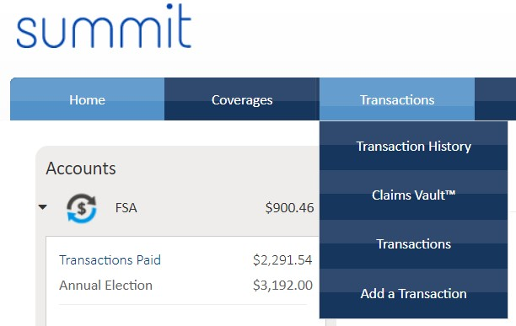
* **Choose Online Claim**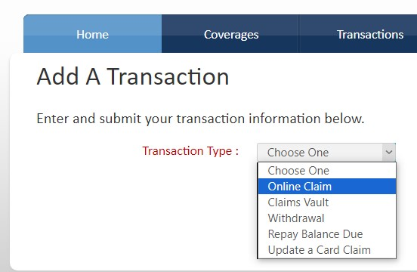
* **Click the green Upload a file button and upload your receipts or EOB.**

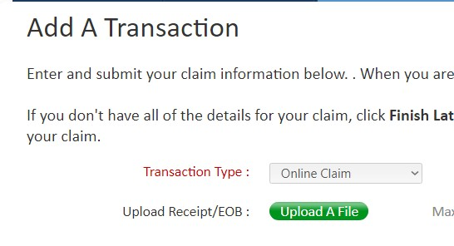

* **Enter the claim date, amount and service category. The service category will be either Medical (FSA) or Dependent Care (DCAP) only. All other categories will not work and will cause your claim to be denied.**

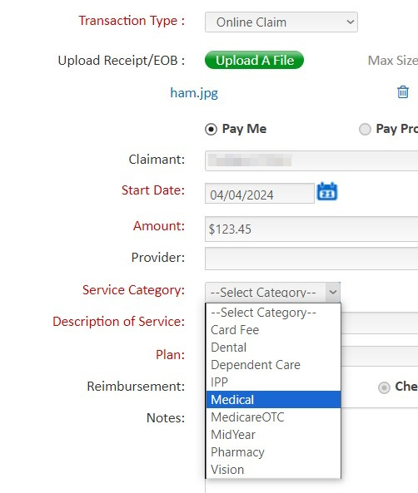

* **Select Service Code. If your service type is not listed, use the Office Visit code.**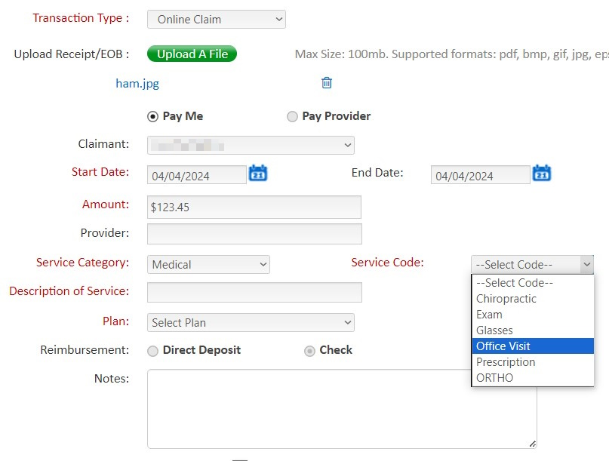
* **Enter a generic Description of Service. Select the Plan type. This will be either DCAP Dependent Care or FSA Flexible Spending Acct. If you are given a choice of two plan years, choose the earlier one. This will only happen from January through March (Grace Period). You can add notes if you like, it is not required. Click the Terms and Conditions box, then click the green Submit button.**
* 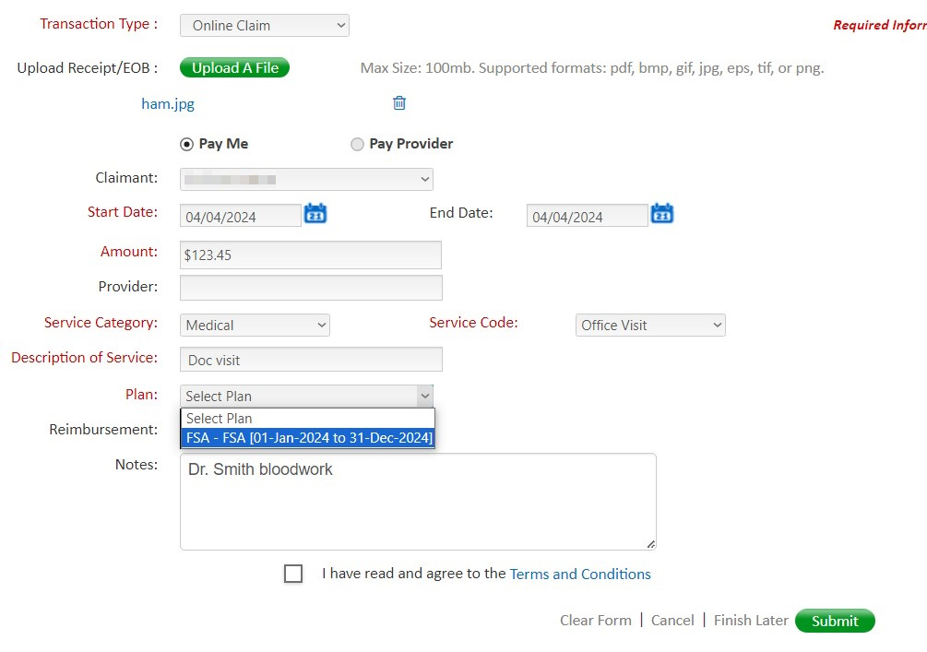
* **Click the X at the top right of screen to finish or enter another claim**
* **Total all uploaded receipts and complete one claim form. Do not combine Dependent Care and FSA claims, they must be separate**.